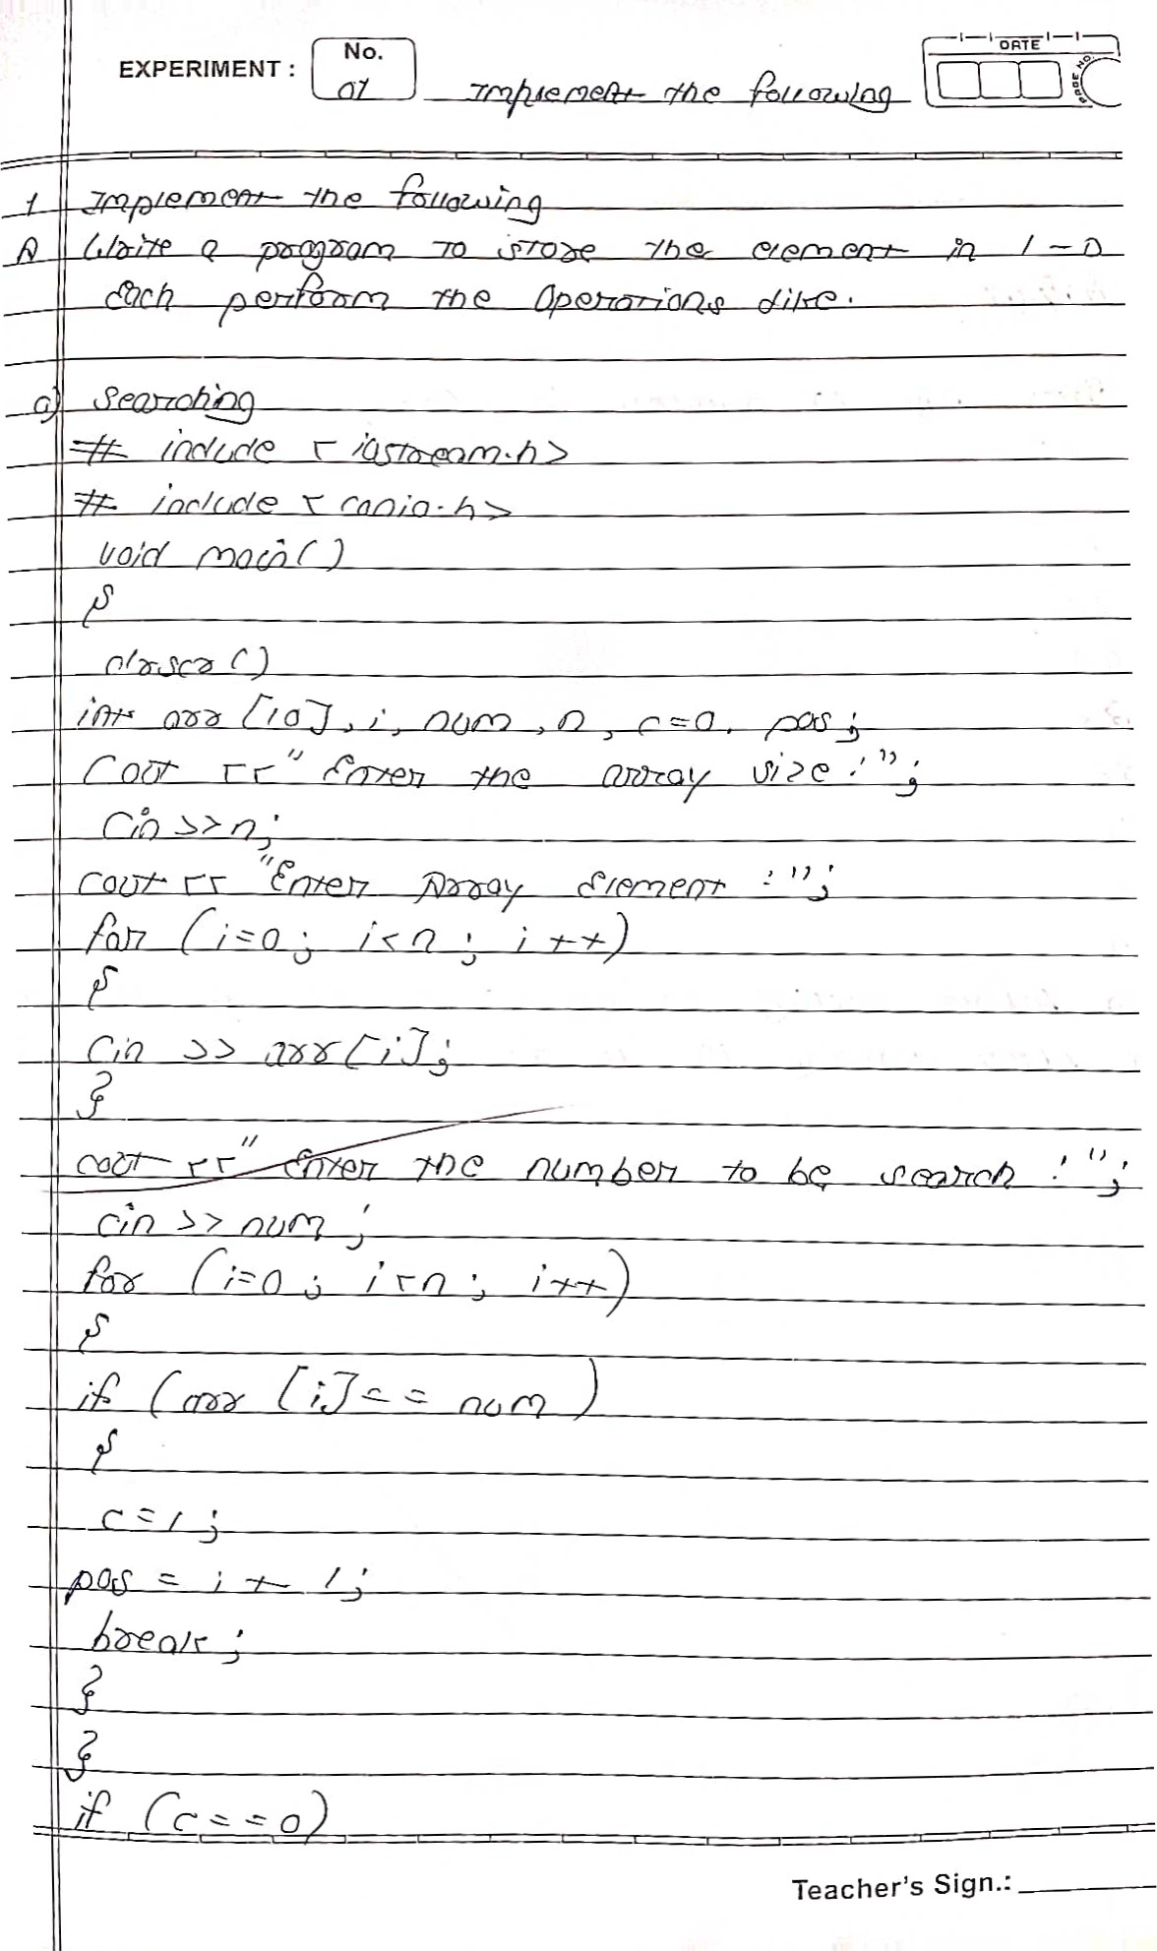

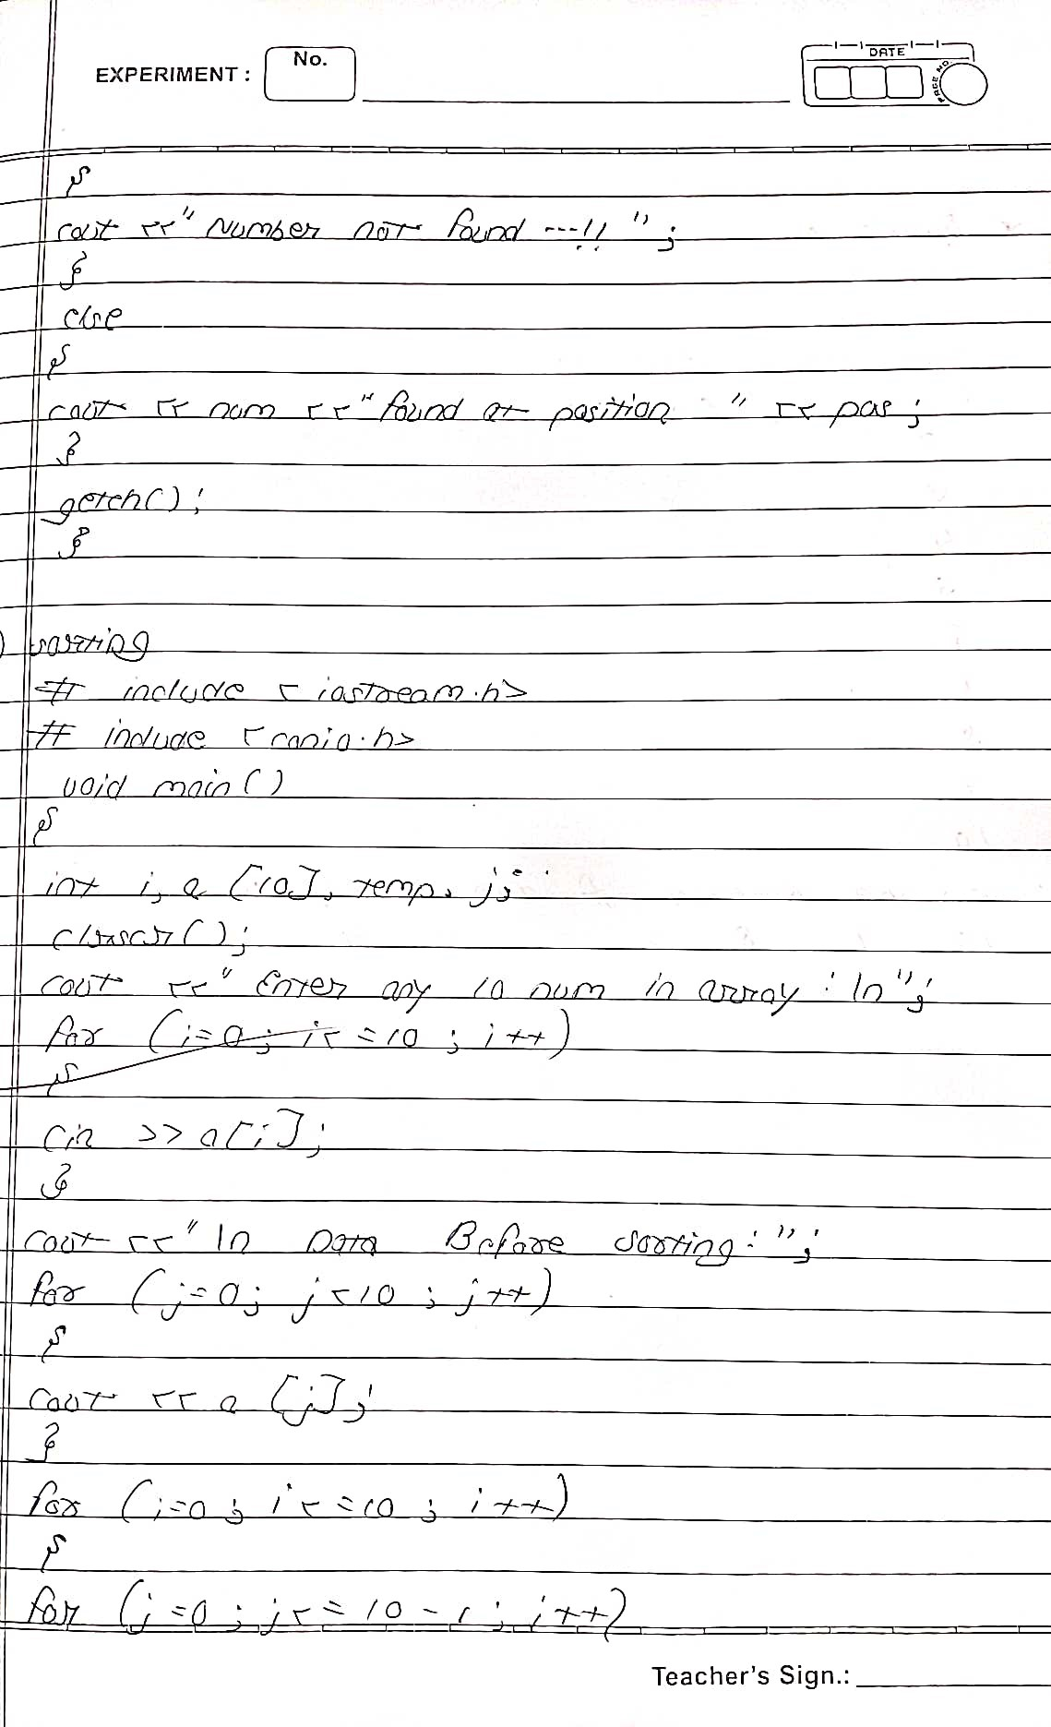

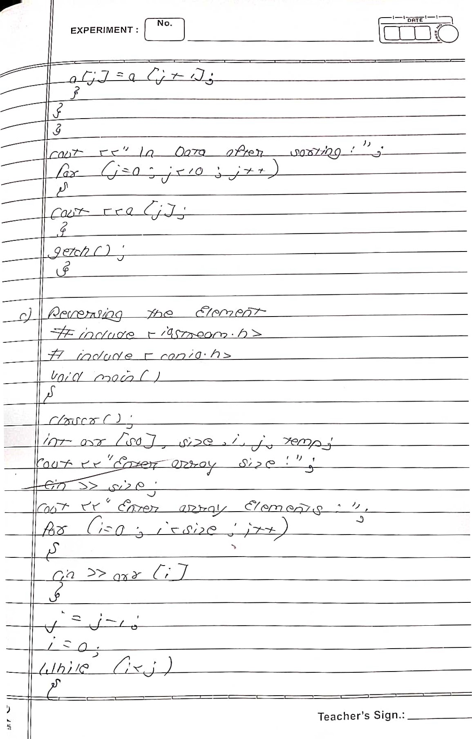

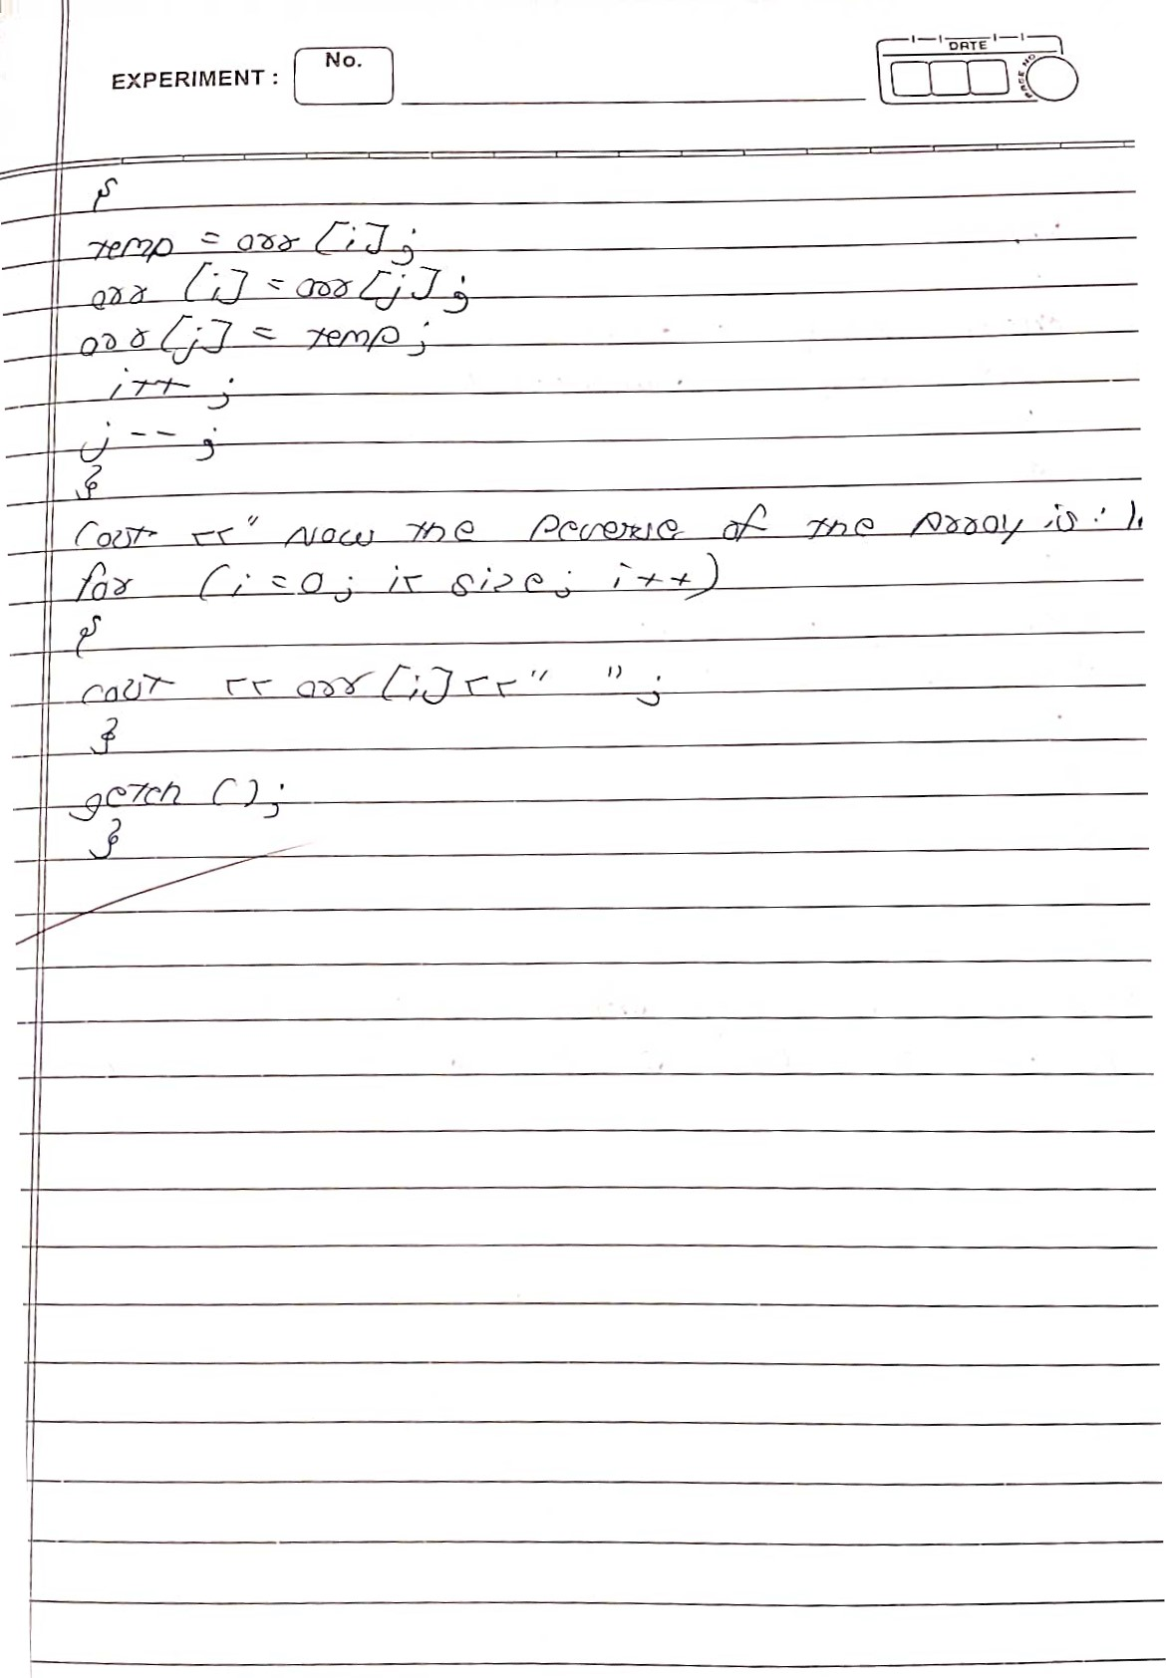

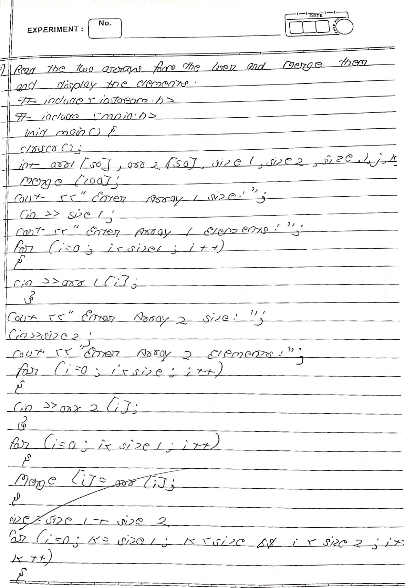

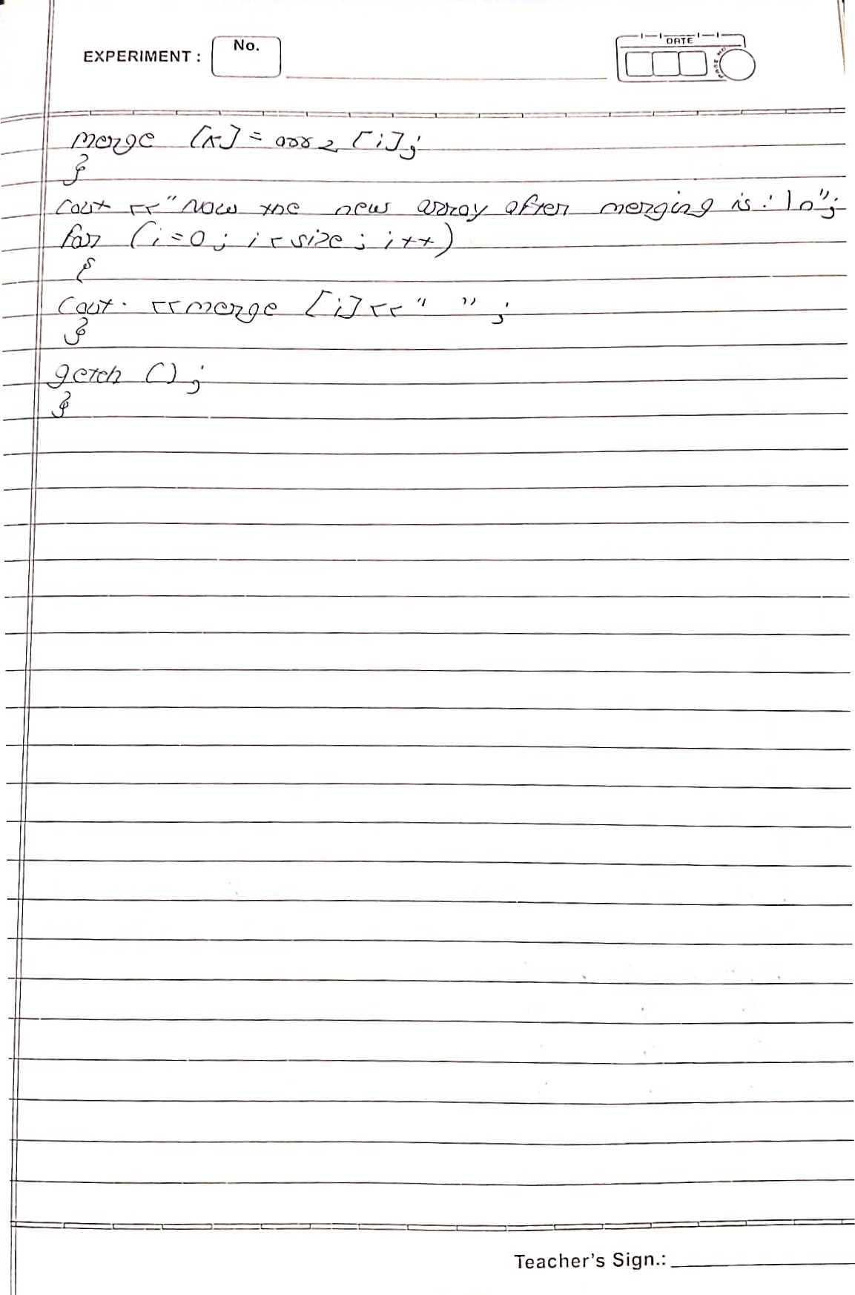

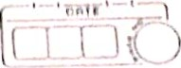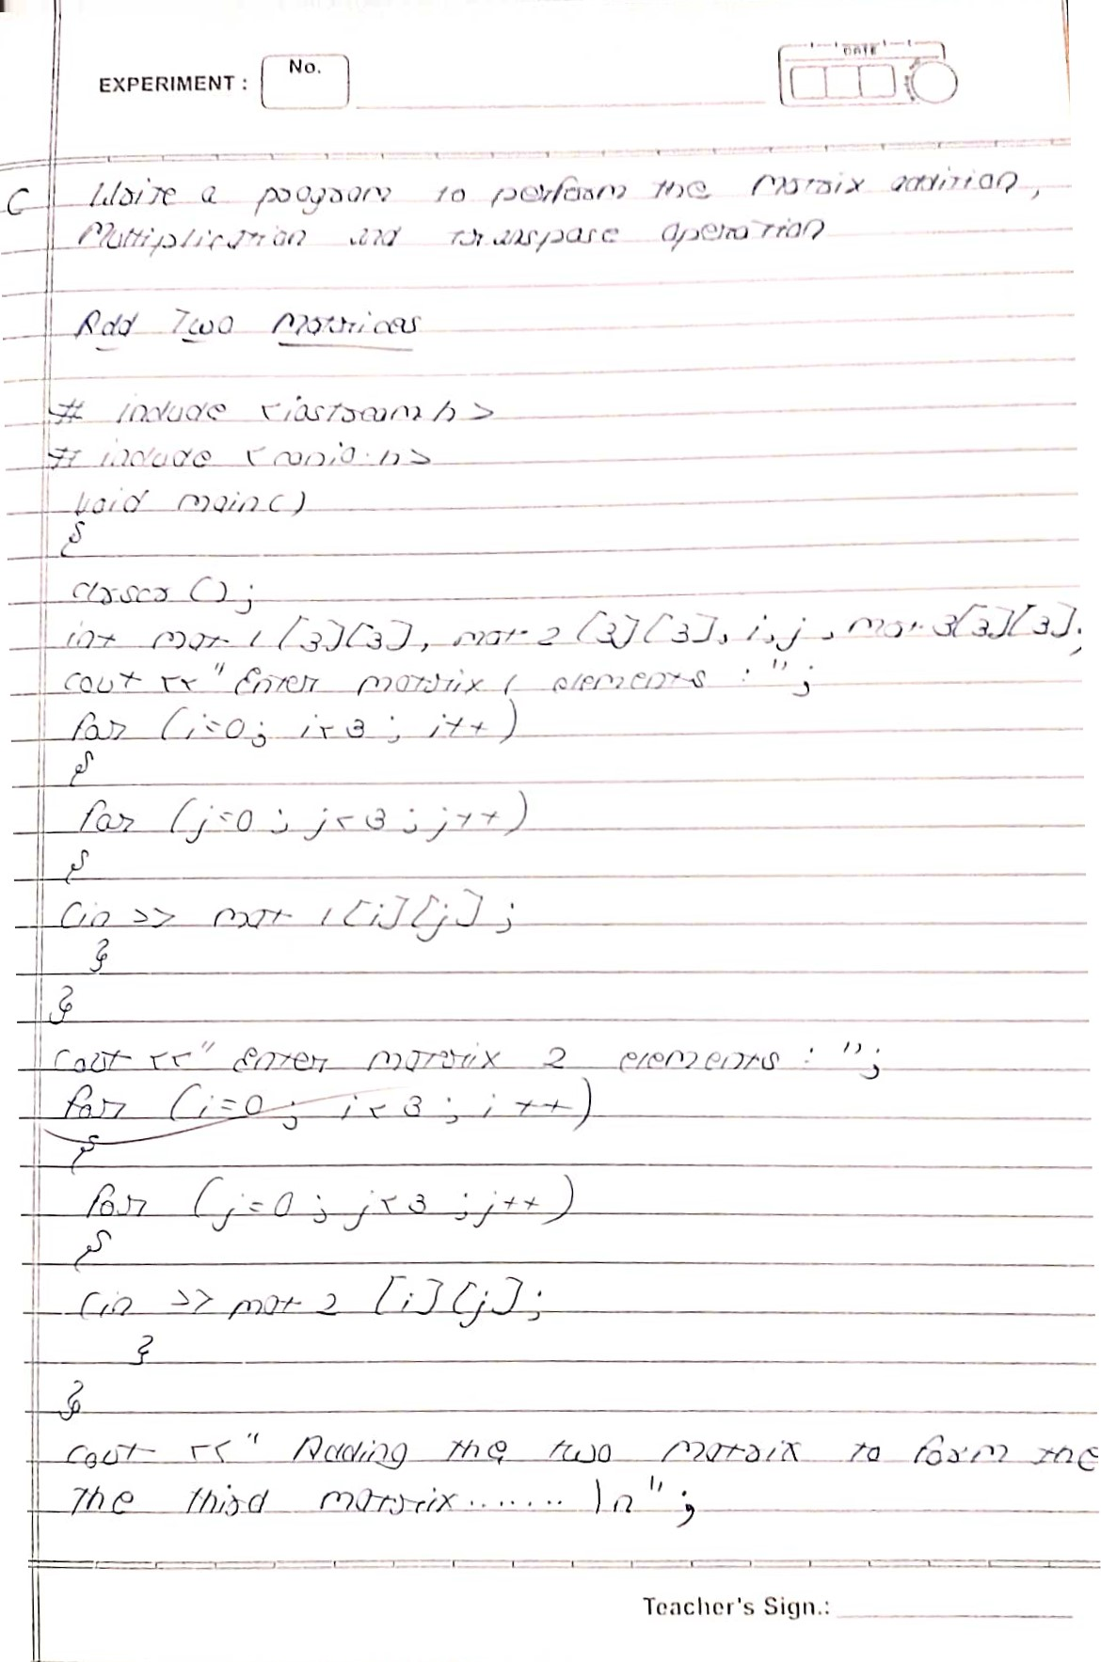EXPERIMENT .

)んで一一は一 /29ツ0 を0ン/ら込/-リ

し彎/.) /,いノ ., 厚 ・0い 山ンっは「0 (ク リれ)ー/朝/ノ

|  |
| --- |
|  |
| can o |

|  |
| --- |
| No. |

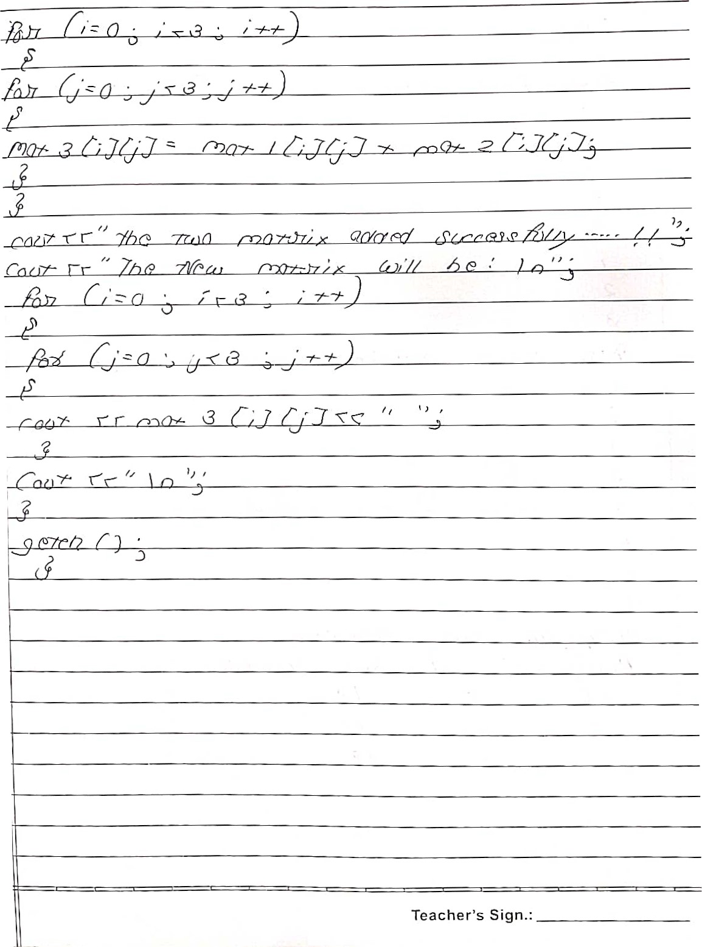:

|  |  |  |
| --- | --- | --- |
|  | |  |
|  | |  |
|  | |  |
|  | |  |
|  | |  |
|  | |  |
|  | |  |
|  | |  |
|  |  |  |
|  |  |  |
|  |  |  |
|  |  | |
|  |  | |
|  |  | |
|  |  | |
|  |  | |
|  |  | |
|  |  | |
|  |  | |
|  |  | |
|  |  | |
|  |  | |
|  | |
|  | |
|  |  | |
|  |  | |
|  | |
| Teacher's Sign | |

|  |
| --- |
| EXPERIMENT . |
|
|

[Cry 0

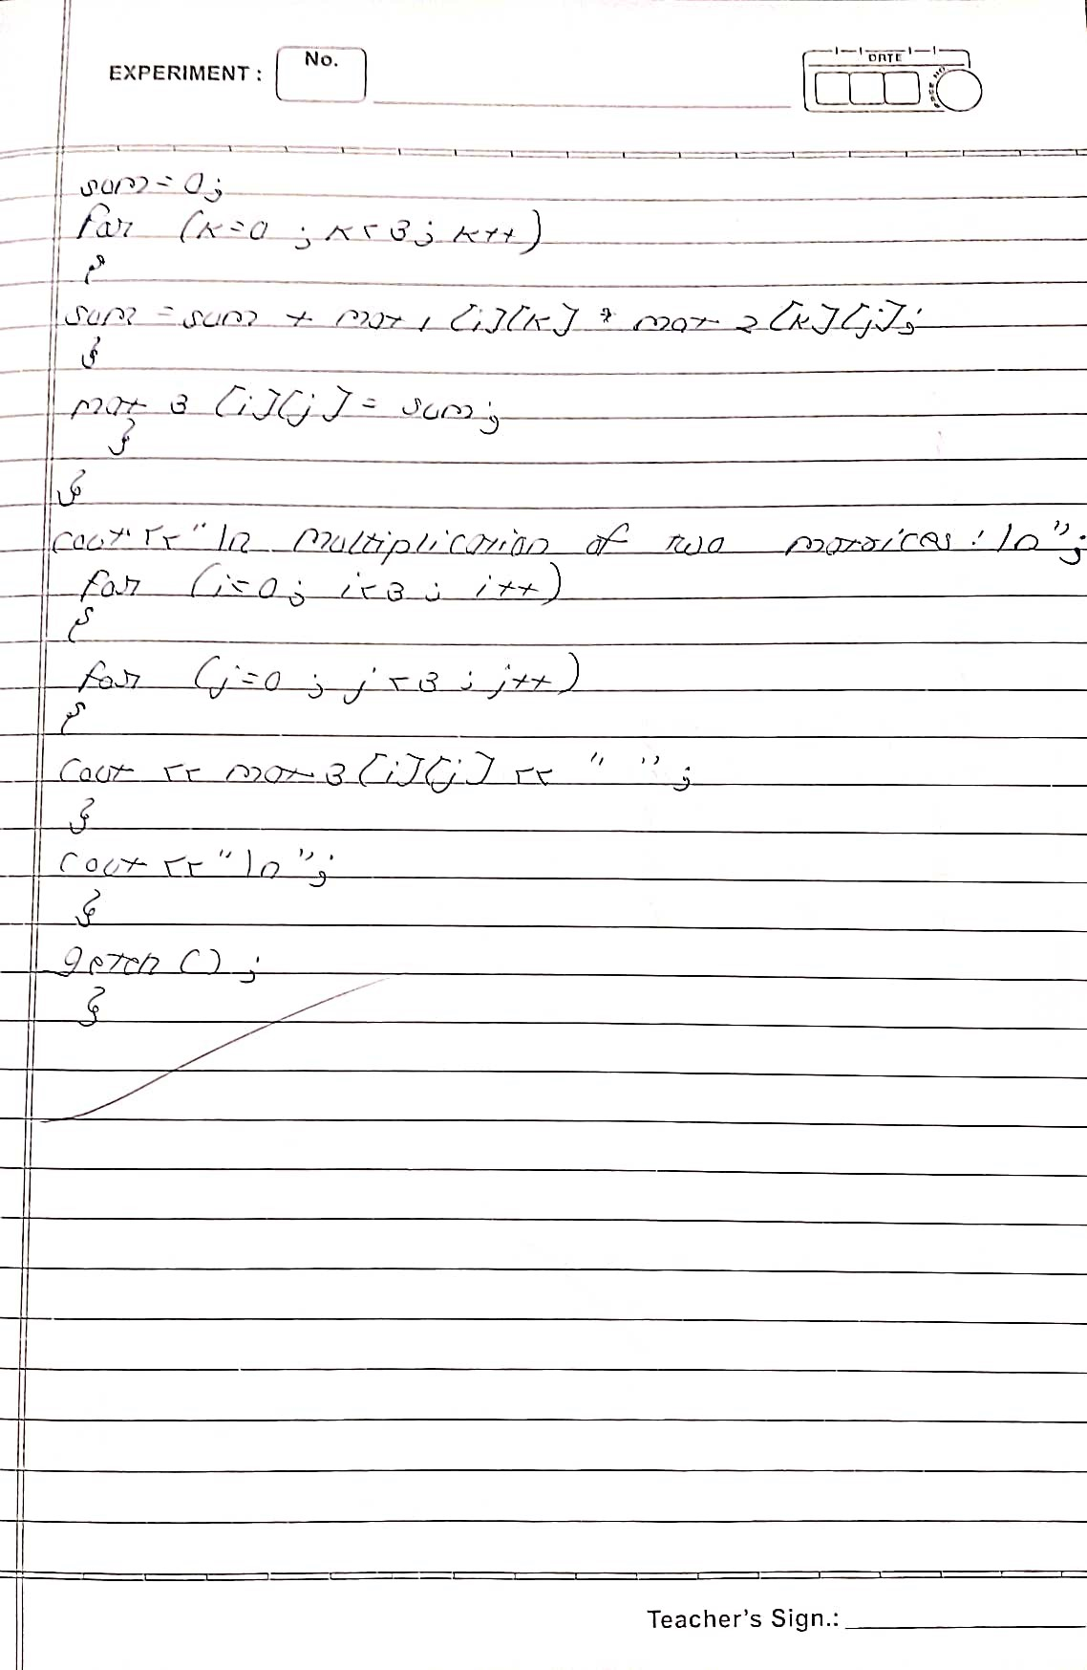

|  |  |
| --- | --- |
|  |  |
|  | 7-7 |
|  |  |
|  |  |
|  |  |
|  |  |
|  |  |
|  |  |
|  |  |
|  |  |
|  |  |
|  |  |
|  |  |
|  |  |
|  |  |
|  |  |
|  |  |
|  |  |
|  |  |
|  | Teacher's Sign.: |

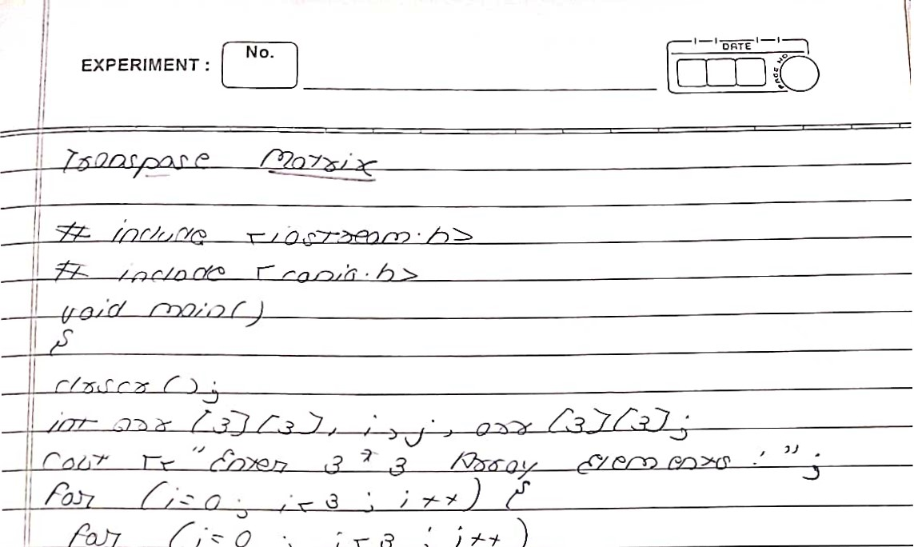

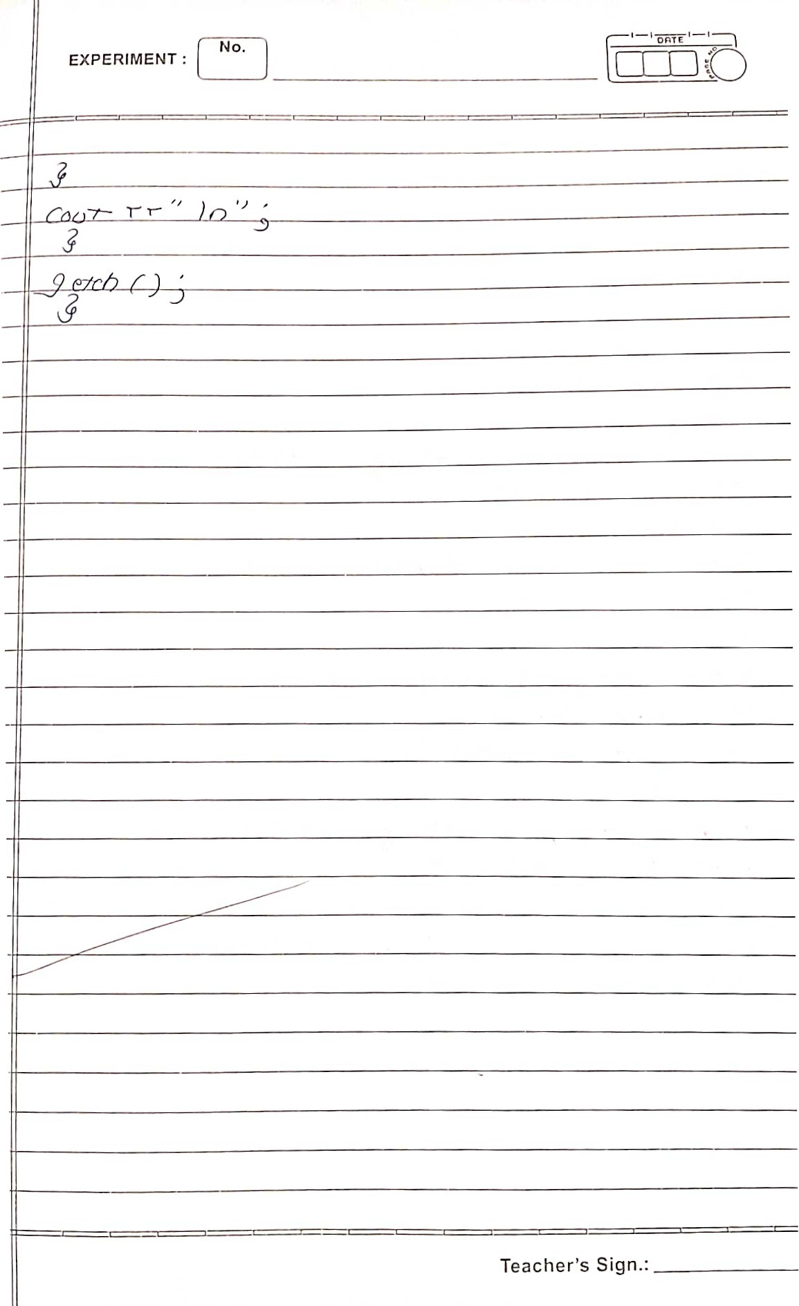

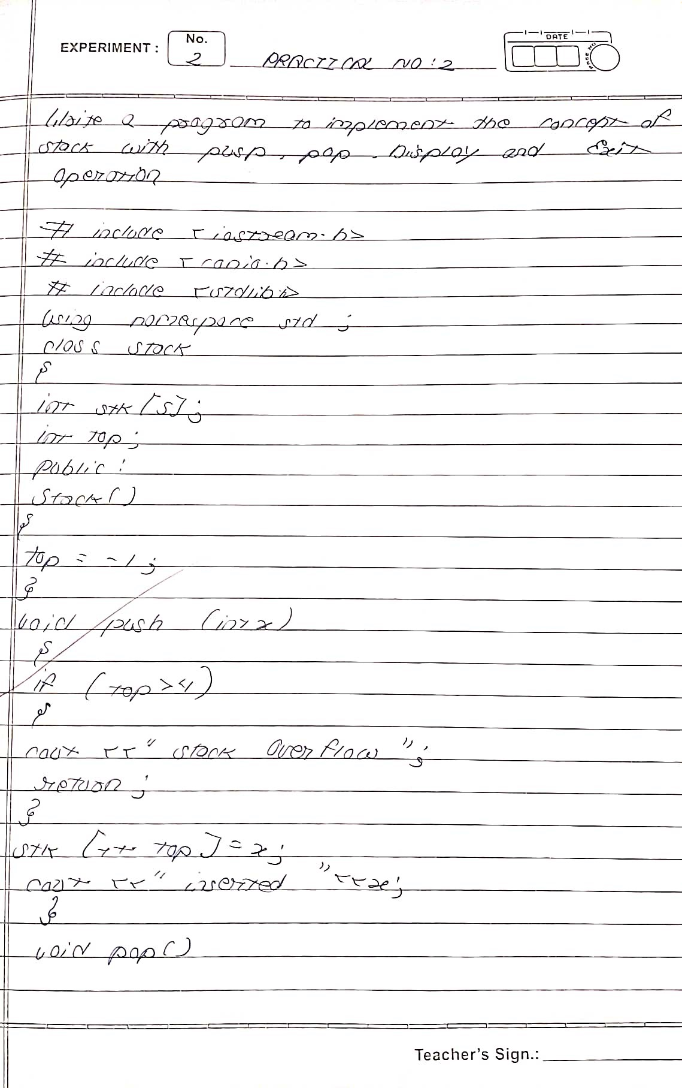

|  |  |  |
| --- | --- | --- |
|  | |  | | --- | | No. |   EXPERIMENT : |

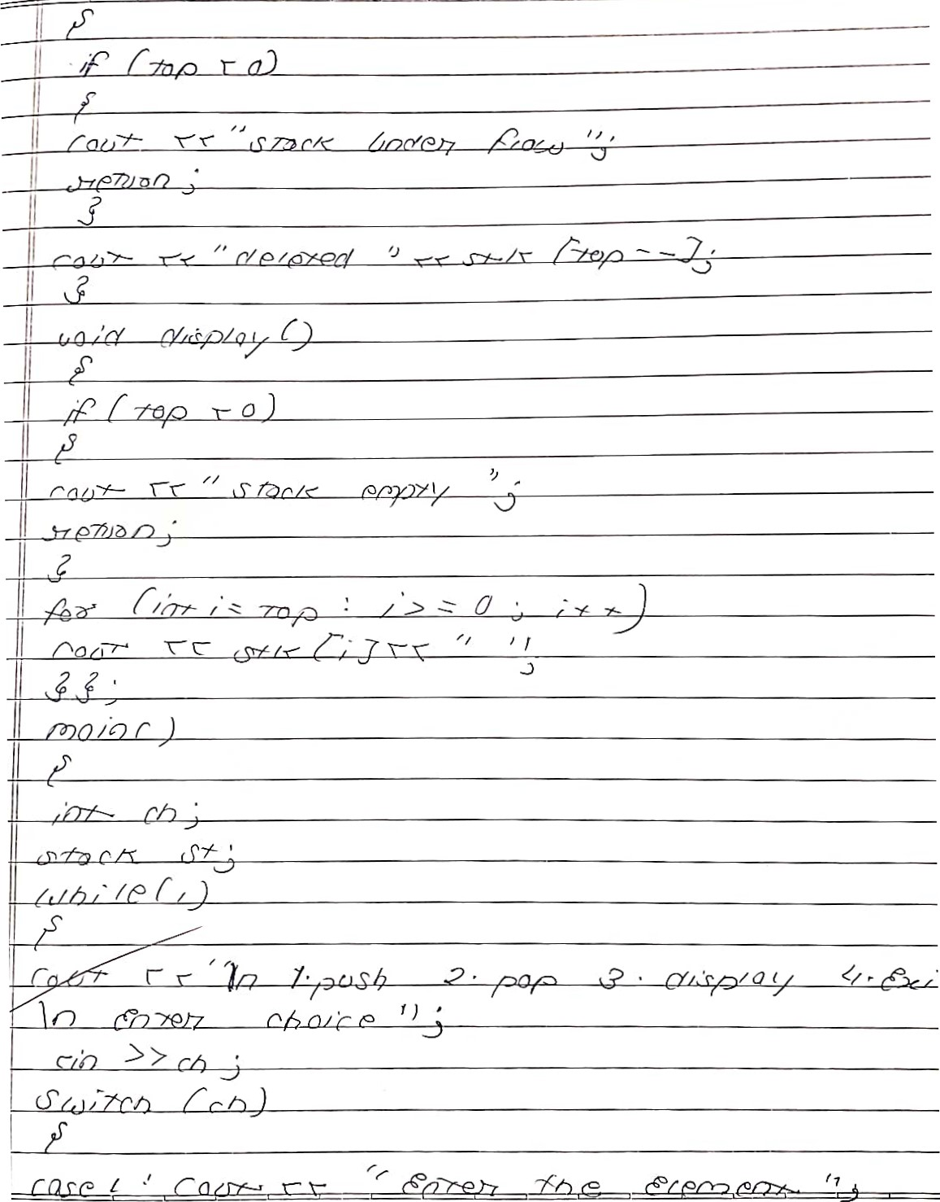

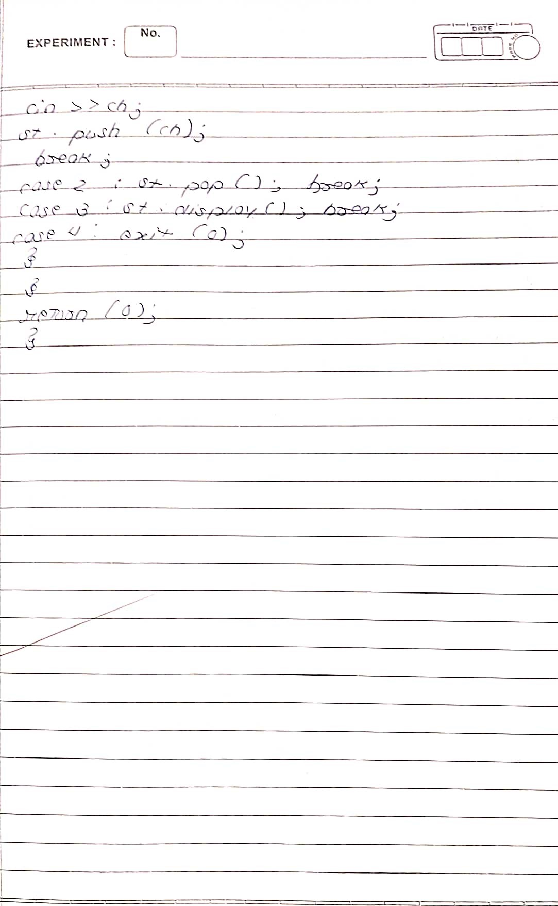

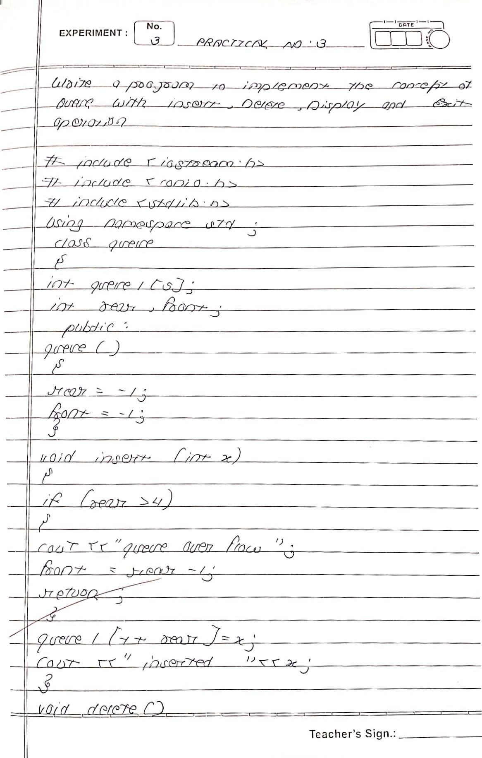

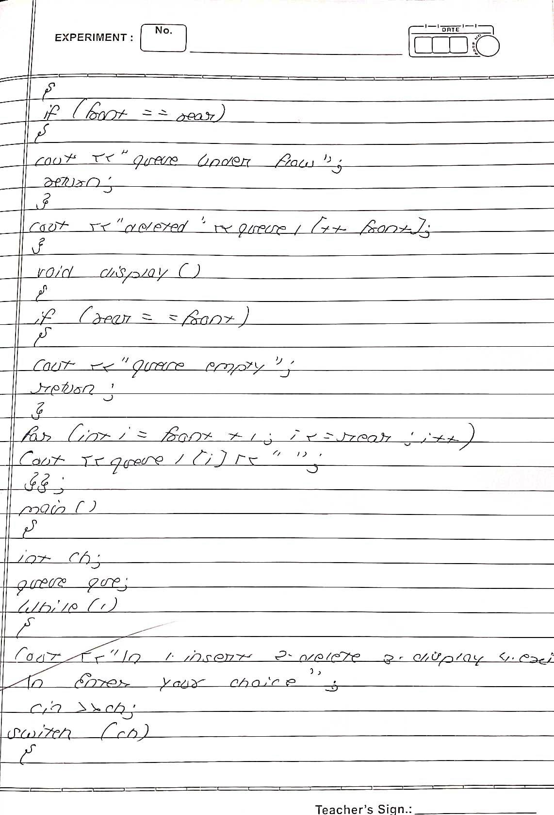

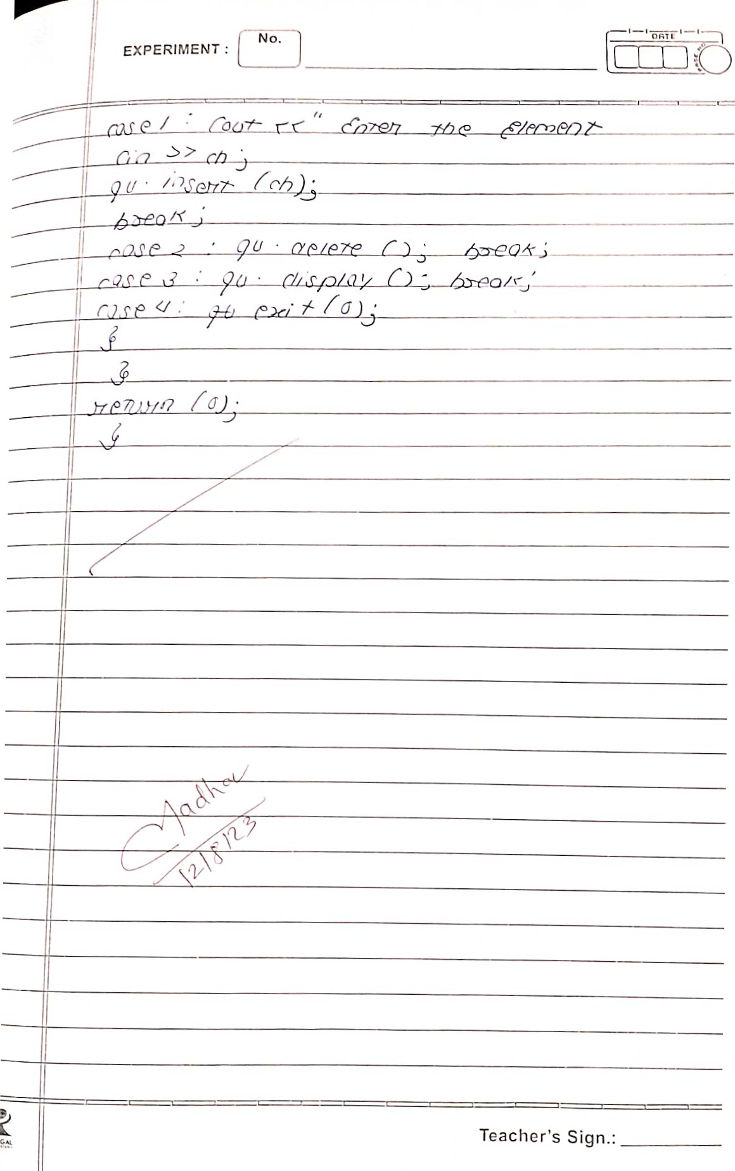

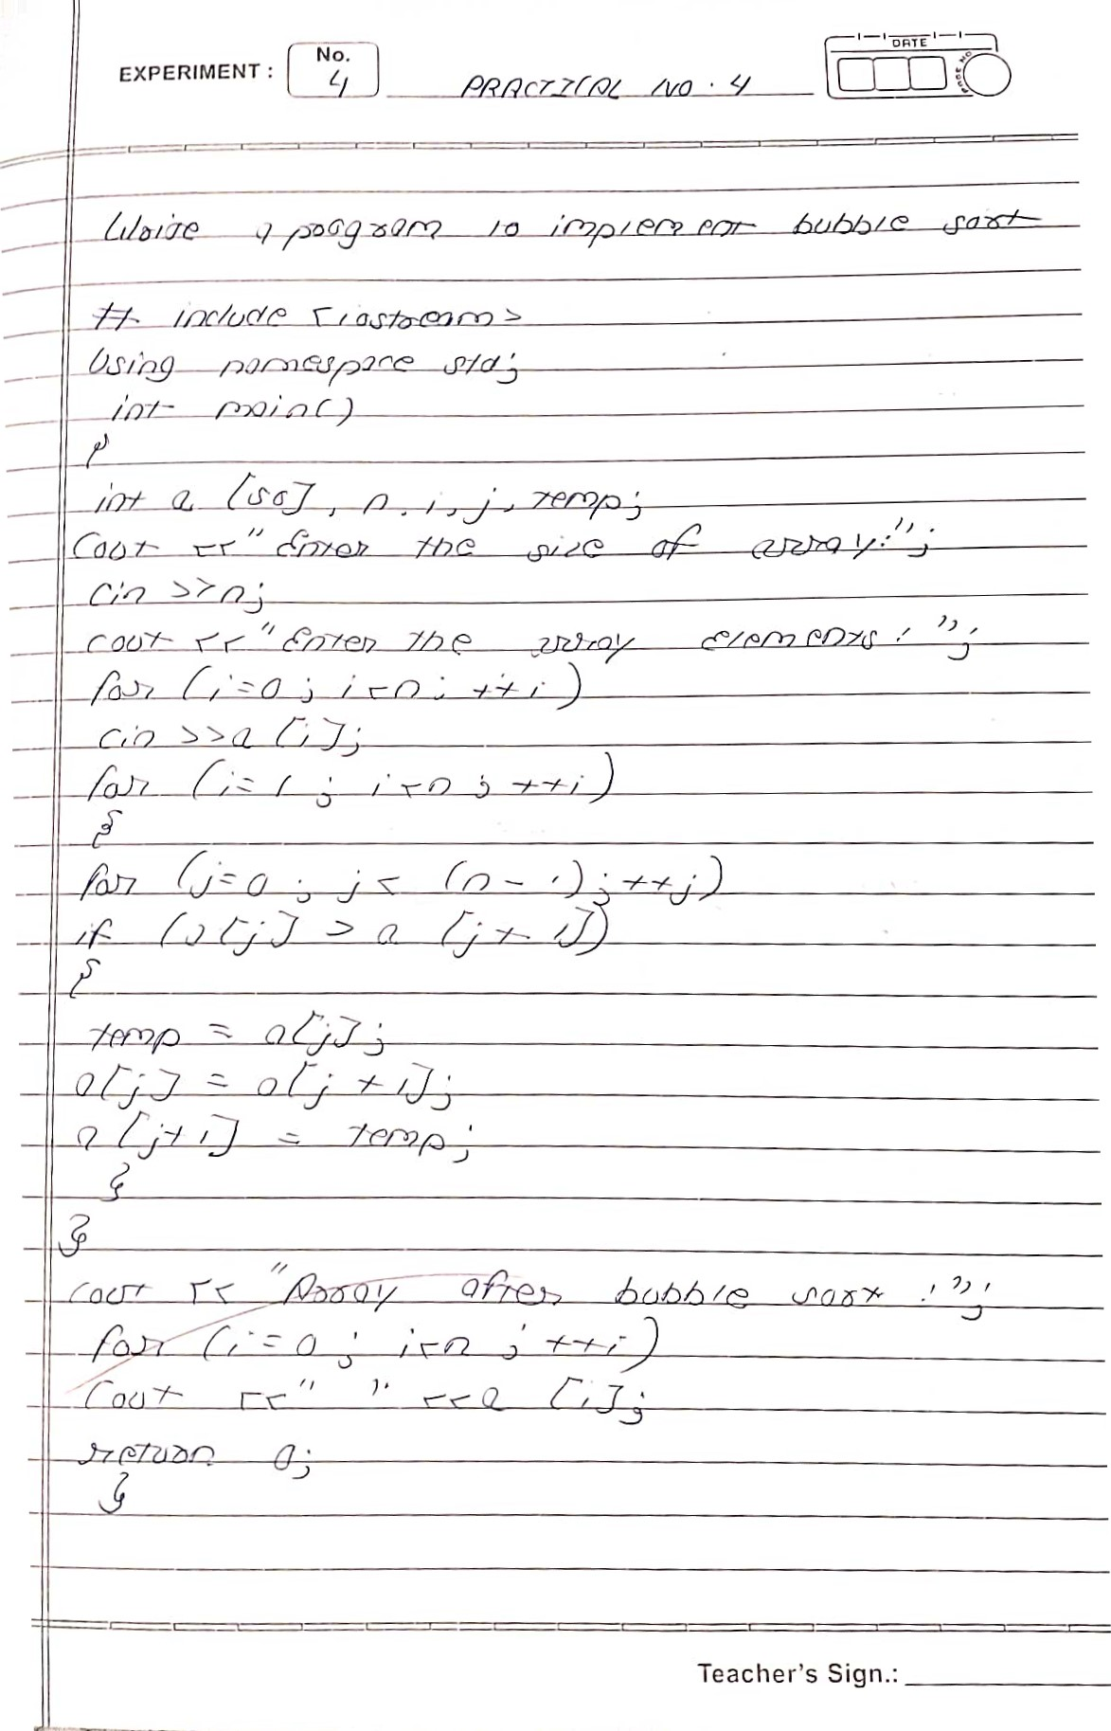

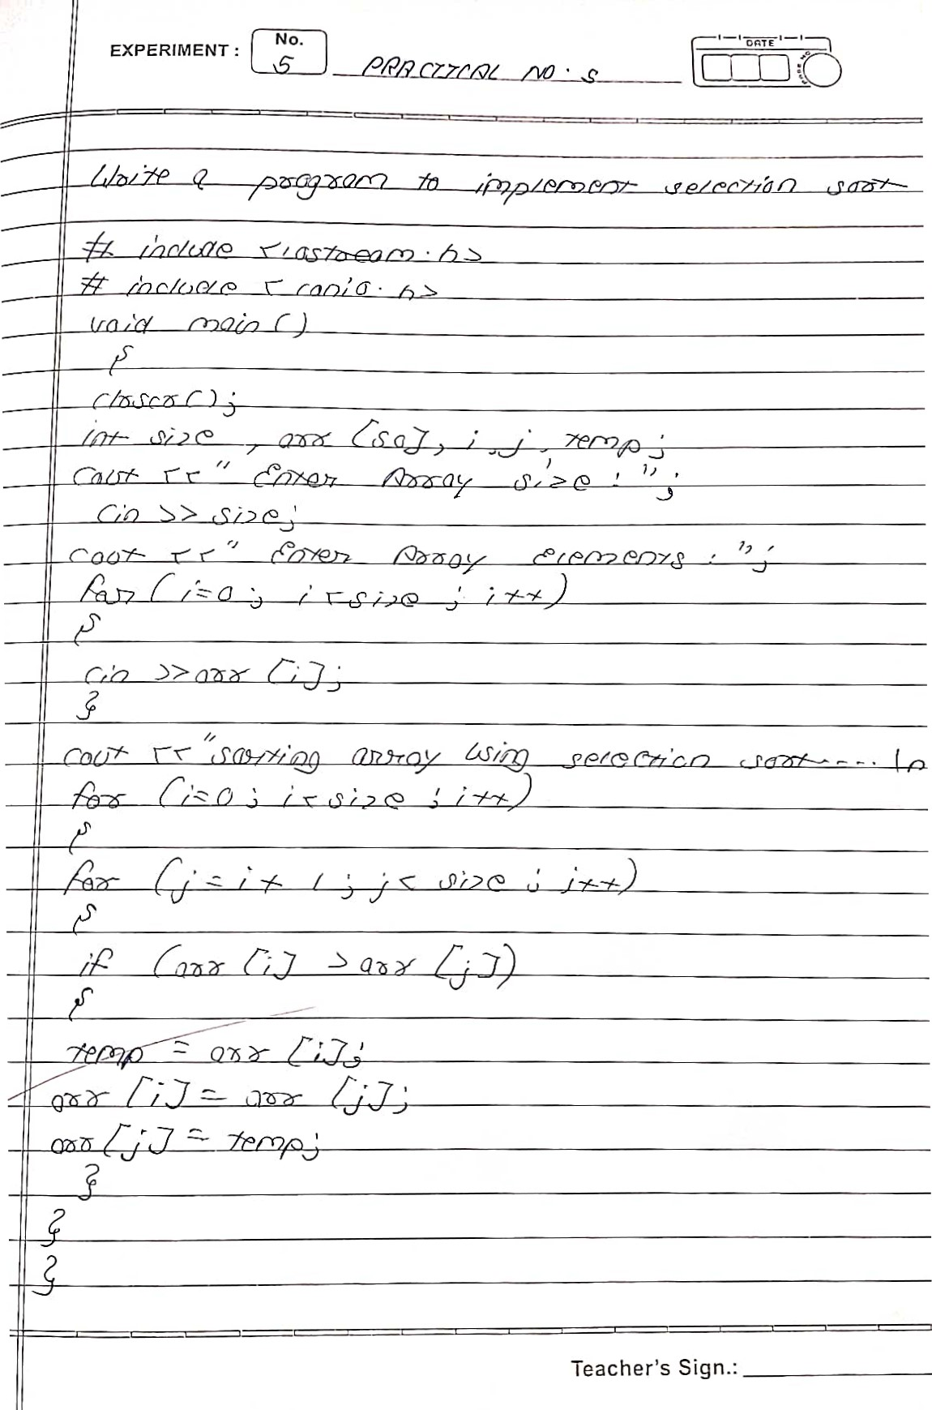

|  |  |
| --- | --- |
|  | Teacher's Sign.: |

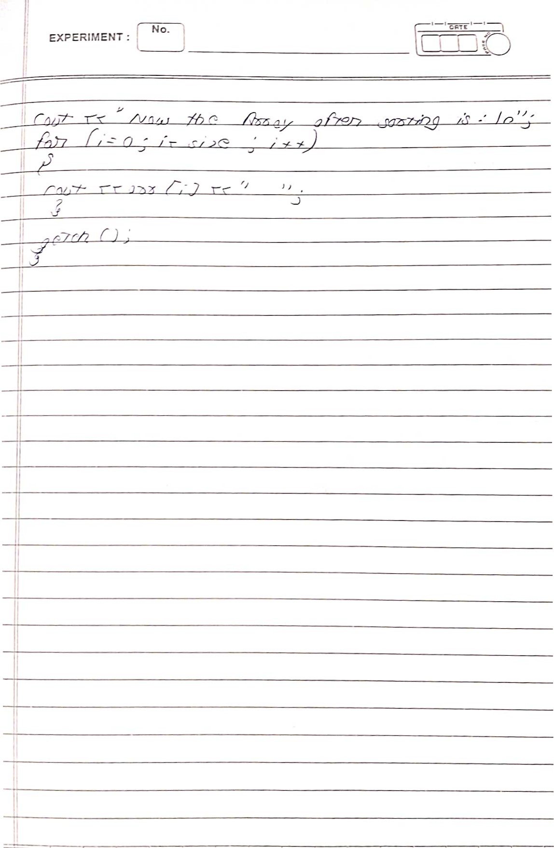

|  |  |
| --- | --- |
|  |  |
|  |
|  |
|  |  |
|  |  |
|  |  |
|  |  |
|  |  |
|  |  |
|  |  |
|  |  |
|  |  |
|  | |
|  | |
|  | |
|  | |
|  | |
|  | |
|  | |
|  | |
|  | |
|  | |
|  | |
|  | |
|  | |
|  | |
| Teacher's Sign.: | |

|  |  |
| --- | --- |
|  | EXPERIMENT : |
|  |
| (t(Dtho  TO |
|  |
|  |

|  |
| --- |
|  |
|  |
| Teacher's Sign.: |
|

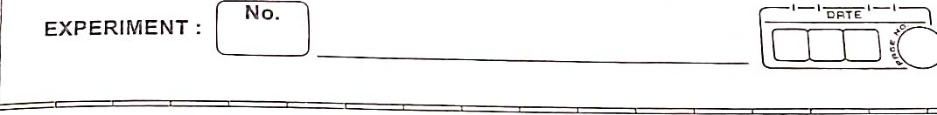

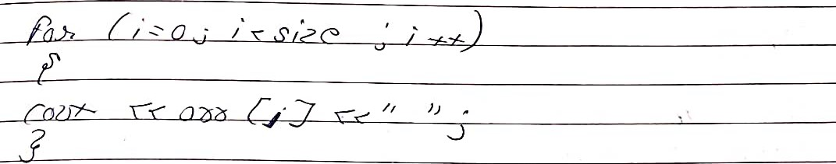



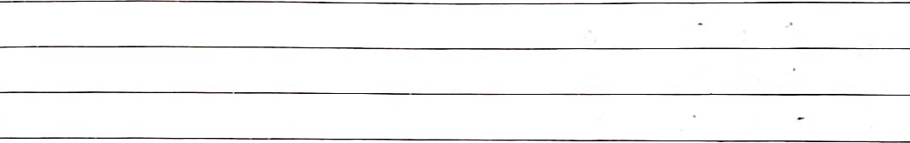





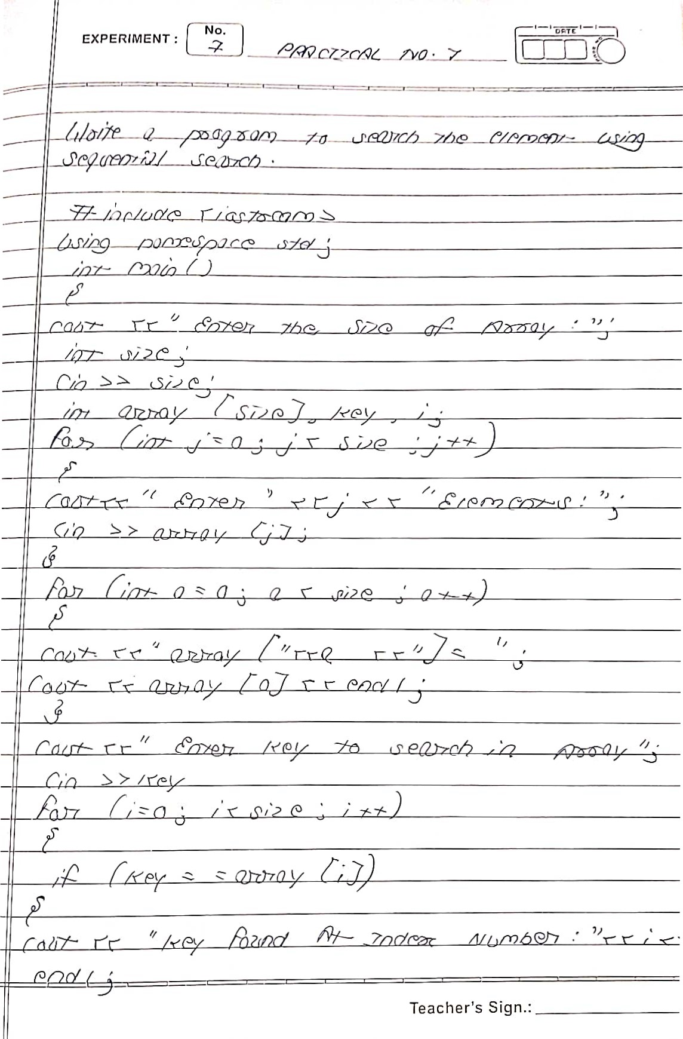

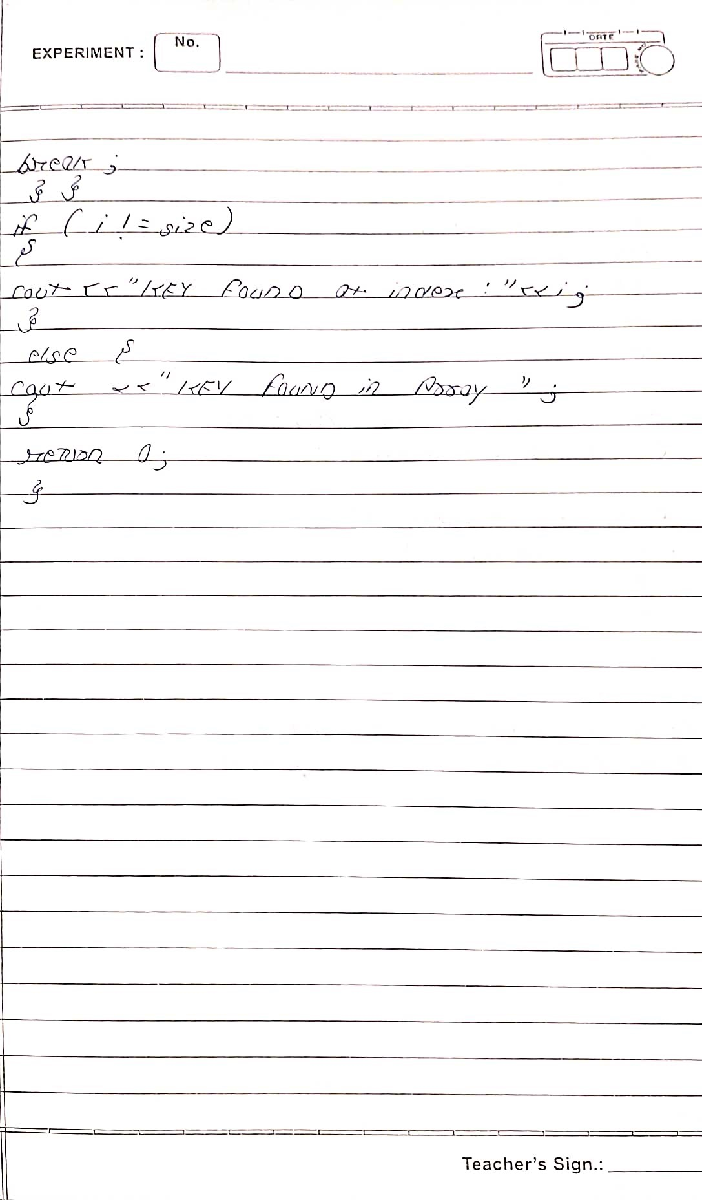

|  |  |
| --- | --- |
|  | Teacher's Sign. |

